SIEMENS SCHOLARSHIP PROGRAM

BATCH 6

A Report on

ONLINE DIGITAL RESUME MAKER

https://resumemakermakeiteasy.000webhostapp.com/#

PROJECT TEAM

SAKSHI T
VIDYASHREE U
SHRADDA M
NISCHITHA
Y KAVYA

TABLE OF CONTENTS

ABSTRACT
1.INRODUCTION
2.DEFINITIONS
3.COMPONENTS OF RESUME
4.REQUIREMENTS
5.FEATURES
6.CONNECTIVITY OF MySQL TO PHP
7.DATAFLOW DIAGRAM
8.WORKING PROCEDURE
8.1 INPUT PROCEDURE
8.2 OUTPUT PROCEDURE
9.CONSTRAINTS
10.FIRST LEVEL DATAFLOW DIAGRAM OF ONLINE RESUME MAKER
11.IMPORTANCE OF RESUME MAKER
12.DO’S
13.DON’TS
14.APPLICATIONS OF RESUME MAKER
15.ADVANTAGES OF RESUME MAKER
16.DISADVANTAGES
17.CONCLUSION
18.REFERENCES

2

ABSTRACT

It is an application that simplifies the task of creating a resume for individuals. The system is flexible to be used and reduces the need of thinking and designing an appropriate resume according to qualifications. The system is developed to provide an easy means for creating a professional looking resume. Individuals just have to fill up a form that specifies questions from all required fields such as personal questions, educational, qualities, interest, skills and so on. The answers provided by the users are stored and the system automatically generates a well structured resume. Users have option to create resume in any format and file.
1.INRODUCTION
It’s hard to pin down exactly what is meant by “digital resume,” because people in different lines of work have come up with incredibly varied definitions, some with all kinds of bells and whistles and some pretty standard. Generally speaking, the only real requirement for a resume to be “digital” is that you can link to it on the web. That means that the information about your work history that you put on LinkedIn, for example, is a digital resume. Likewise, so is the PDF you uploaded to your website or to a resume database. But the term “digital resume” can also include things like graphs, videos, and links to writing, images, and
3
projects you’ve done, as well as your social media profiles. Basically, the sky is the limit as far as creativity goes, and if you are in a creative industry, it’s probably in your best interest to go all out and really try to catch people’s attention by making it as visually interesting as possible

2.DEFINITIONS

Definition of resume

A resume is a short document (most of the recruiters recommend limiting it to one page only) that summarizes your relevant professional experience, skills, and education that you need to prepare when applying for a job.

You can also view the resume as a marketing document. The resume will introduce you to the potential employer, and you want to make a good first impression.

Its purpose is to advertise YOU and explain what value they will get by hiring you and how their problems (from the job ad) will be solved.

Definition of resume builder :

4

3.COMPONENTS OF RESUME
There are literally hundreds of books and articles available on the "perfect resume." Many suggest their approach to resume design will assure you an interview. Additionally, there are numerous resume services that will design and write your resume for fees. The best resume for you will be one that you do yourself. Avoid resume templates and instead think of your resume as an advertisement.
Typically, a resume will include the following parts:
Header

Include your name, full address, phone number and email. Generally employers will contact you via phone or email. For this reason, it is no longer necessary to provide two addresses if you are relocating in the near future.
Professional Objective (optional)

This is a phrase or sentence that highlights your intentions and accomplishments. Be specific enough to give an element of career direction to your resume. Tailor this to each organization and position. State clearly whether you are looking for an internship, part-time or full-time job. If you are designing the resume for a job fair, convey broad interests. Highlight your key qualifications instead of personal preferences, such as advancement opportunities. NOTE: An alternative is to exclude a career objective from your resume and relay the information in the cover letter.
5
Qualifications Summary (optional)

In lieu of an objective, you may use a qualifications summary to highlight your most noteworthy attributes. This typically includes your years of experience, technology proficiency, languages and highest achievements. This may also contain a keyword section. Your resume should then support these attributes by providing evidence throughout the remaining document.

Education

List the highest level of education first. Include the name of the college, degree, major, minor, and month and year of your anticipated graduation. Dates of attendance or high school information is not needed. If you transferred to Augustana, only note your previous institution if you earned a certificate or degree. Include your GPA if it is above a 3.0, as well as any other academic honors, relevant coursework, study abroad participation or major research projects. Note: Augustana awards Bachelor of Science degrees to nursing majors. Art majors may choose to earn either a Bachelor of Fine Arts or a Bachelor of Arts degree. The rest of our majors earn a Bachelor of Arts degree.

Experience

This category typically reflects your contact with specific employers. Include co-ops, internships, part-time, jobs, volunteer work, summer jobs,
6
special projects or military experience under this category. You do not need to include all of your previous jobs, only those that relate to the position you are seeking. As you progress in your studies at Augustana avoid including outdated high school achievements. List position titles first, followed by the names of organizations, locations (city and state), dates (month and year) and duties. Each descriptive phrase begins with a strong action verb. Use present tense for current positions and past tense for previous jobs.

References

Generally references are not listed on a resume and only provided if requested by an employer. To share your references, list in alphabetical order the names, titles, addresses, telephone numbers and e-mail addresses of at least three people on a separate page. Include your contact information in a format consistent with your resume in the event that your resume and reference list are separated. People who have known you for at least a year and within a context similar to the position you are seeking will provide the strongest endorsements. Faculty are often your best source of references since they have assessed the knowledge, skills and abilities that employers are often seeking. Whomever you select, remember to ask these individuals for permission before listing them as a reference. Provide them with a copy of your resume and the job description to enhance their ability to speak to your qualifications. Always thank your references once you accept an offer. They like to celebrate your achievements!
7
Other possible headings to consider include the following:

- International Experience
- Professional Affiliations & Memberships
- Publications & Presentations
- Languages
- Community Service
- Technology Skills
- Honors & Awards
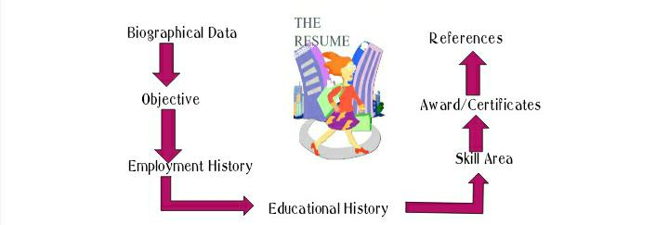
- Leadership Activities
- Collegiate Involvement

8
4.REQUIREMENTS
- Hardware Requirements
  - Printer
- Software Requirements
- Database MySQL
- HTML
- CSS
- PHP
5.FEATURES
1) Communication skills:
Communication skills are hugely important for anyone dealing with people on a daily basis. Speaking to IT guys can be drastically different to speaking with HR. Your ability to communicate is the number one factor for you career progression so you need to show initiative here. Example: “I joined Toastmasters 2 years ago and I am currently working towards my advanced speaker certification”.
2) Openness:
This means openness to new ideas, new processes, new people and so on. As corporations are ever changing entities, your ability to change with it is crucial. You will have to demonstrate how you adapted in the past and how you can do it again. Example: “I tested the new email system quickly learned how to use it, then helped to roll it out across the business and taught it to others across the company”
9
3) Creativity:
This is your ability to engage in non-linear thinking or thinking outside the box to use a nice cliché. An employer needs people that not only point out what is wrong in a process for instance, but can also come up with a better way of doing things. Example: “I spotted an opportunity and developed a new order process and reduced lead times by 20% across my department”.

4) Cultural Experience:
Denotes what experiences you have had with people from other countries and cultures. You will want to include any language you speak, any time you have spent in a foreign country, any connections you have abroad etc. This can come in handy when a company needs to deal with and even negotiate with international partners. Example: “I lived in Germany for 2 years and speak fluent business German”.

5) Positivity:
Everyone wants a force of positivity on their team. It’s difficult to include this on a resume but you can do your best by using upbeat language and dropping hints of what a happy camper you are in the office. Example: “Working with this team was a fantastic experience, I still keep in touch with all of the great members and I am glad they have all got promoted and wish them all the best”.

10
6) Commitment:
This is your chance to show how you get involved in the corporate culture and really try to live and breathe what your company is all about. Example: “I have carefully studied the company’s vision statement and refer to it almost daily when I need guidance on daily and longer term tasks”.

7) Enthusiasm:
This is all about what lengths you go to in order to further your career. Extra-curricular activities can benefit your potential new employer. Example: “I joined the local chapter of the Chamber of Commerce Networking Group in order to build up my network of industry peers”.

8) Integrity:
You would think it should hopefully go without saying that you have the integrity required for customers and co-workers to trust and work successfully with you. In order to reiterate this point you could write what others’ experiences of you have been. Example: “When my manager needed someone trustworthy to look after the new office, she picked me out of 8 internal candidates”.

9) Team spirit:We can assume that you are a team player, everyone that works in an office is required to be or they would get the axe sooner than a Frenchman can spell esprit de corps. Team spirit is more than simply
11
playing, it’s actually taking the initiative and activating a group of people and creating closer bonds. Example: “I organized a paintball day out for junior staffers and the top executives, in order to create a sense of belonging for the newbies”.

10) Community service:
Everyone claims to have a big heart but only a few can actually quantify what their charitable accomplishments are. This is about you making a difference and being able to tell the world how you did it.

6.CONNECTIVITY OF MySQL TO PHP
In the first installment of MySQL series,I introduced databases and database management system. I also presented a brief overview of the popular DBMS software, MySQL. In continuation from the previous post, I’ll be telling you how to connect MySQL Database with PHP file.
When developers usually say database, they are referring to MySQL, a highly popular DBMS that can power projects of all sizes. MySQL’s ability to handle huge volumes of data without breaking a sweat is one of its biggest selling points.
There are three types of methods in PHP to connect MySQL database through backend:
MySQL
MySQLi
PDO
mysql() is now obsolete because of security issues like SQL injection etc,
12
but the other two are being actively used.
MySQLi
It is an API that uses a connector function to link the backend of the PHP app to the MySQL database. It provides a better set of functions and extensions. It works just like the previous version, but it is more safe and faster.
PDO
PHP Data Objects (PDO) extension is a Database Abstraction Layer. It is like an interface for the backend to interact with the MySQL database and make changes without making any change in the PHP code. It also gives you the freedom to work with multiple databases. The major advantage of using PDO is that your code stays simple and portable.
In this ,we discuss how to connect MySQL Database on different servers and I’ll also give you an overview of connecting Database using PDO.
1.Connect MySQL using Localhost Server
2.Connect MySQL using Cloudways Server
3.Connect MySQL using PDO
4.Connect MySQL using Remote MySQL
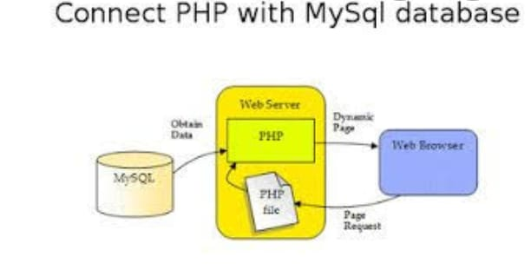

13
7.DATAFLOW DIAGRAM

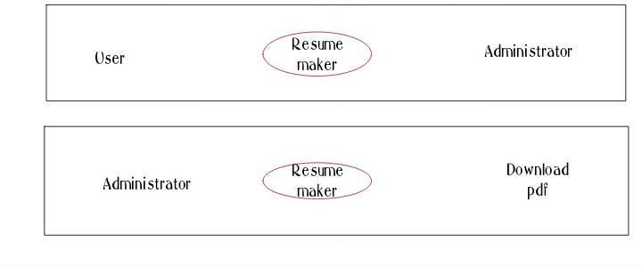
A data flow diagram is graphical tool used to describe and analyze
movement of data through a system. These are the central tool and the basis from which the other components are developed. The transformation of data from input to output, through processed, may be described logically and independently of physical components associated with the system. These are known as the logical data flow diagrams. The physical data flow diagrams show the actual implements and movement of data between people, departments and workstations. A full description of a system actually consists of a set of data flow diagrams. Using two familiar notations Yourdon, Gane and Sarson notation develops the data flow diagrams. Each component in a DFD is labeled with a descriptive name. Process is further identified with a number that will be used for identification purpose. The development of DFD’s is done in several levels. Each process in lower level diagrams can be broken down into a more detailed DFD in the next level. The lop-level diagram is often called
14
context diagram. It consists a single process bit, which plays vital role in studying the current system. The process in the context level diagram is exploded into other process at the first level DFD. The idea behind the explosion of a process into more process is that understanding at one level of detail is exploded into greater detail at the next level. This is done until further explosion is necessary and an adequate amount of detail is described for analyst to understand the process. Larry Constantine first developed the DFD as a way of expressing system requirements in a graphical from, this lead to the modular design. A DFD is also known as a “bubble Chart” has the purpose of clarifying system requirements and identifying major transformations that will become programs in system design. So it is the starting point of the design to the lowest level of detail. A DFD consists of a series of bubbles joined by data flows in the system.

15
8.WORKING PROCEDURE
8.1 INPUT PROCEDURE
First of all this is how our resume look like, these are the some pictures taken from our Resume Maker so to know our Resume Maker in detail.
BASIC
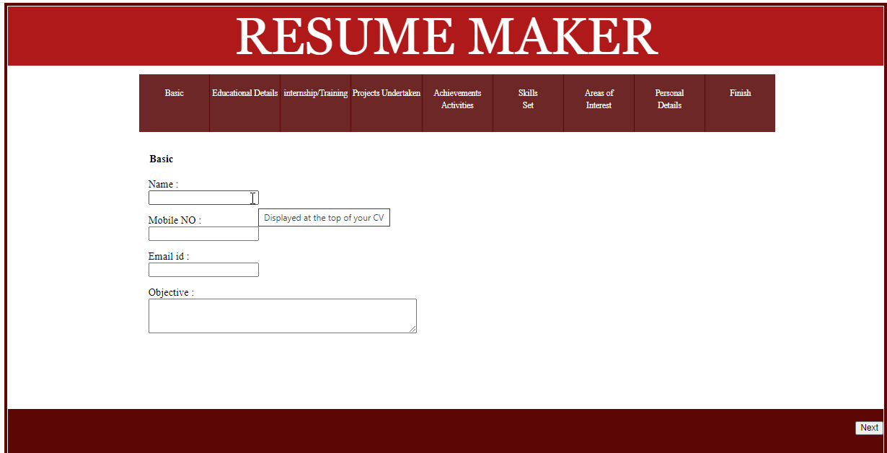
At the beginning it starts with basic which includes Name,Mobile Number,Email ID and Career Objective, which need to be filled compulsorily.Which includes next button.
- Name – Displayed at the top of your CV
- Mobile Number – Primary mode of communication ensure its correctness
- Email ID – Current Mail ID
- Objective – Precise and clearly describing your career objective

16
EDUCATIONAL DETAILS
Here comes the education details of three different graduates they are Diploma graduates , Non Diploma graduates and Only Diploma graduates, which need to be filled as per the passing certificate and this page includes
both back and next buttons.
Diploma graduate
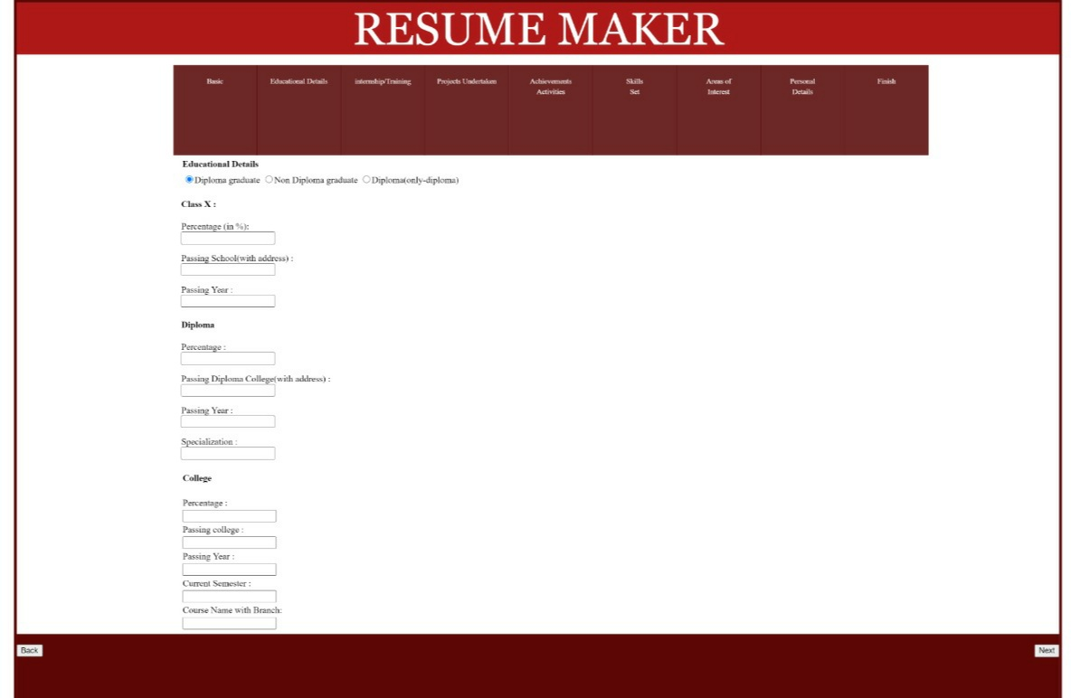
It includes graduates who are diploma plus graduates, in which we have to
fill details of 10th ,Diploma and Degree.
Class 10th
- Class 10th percentage – Input your class 10th percentage
- Passing school – School from which you pass your 10th class
- Passing year – Passing year as printed in your 10th passing certificate
17
Diploma
- Percentage - Input your diploma percentage
- Passing Diploma college – College from which you pass your
diploma
- Passing year – Passing year as printed in your diploma passing
certificate
- Specialization – Name of diploma
College
- Percentage – Till date aggregate percentage in college
- Passing College – Name of the college
- Passing year – Year of passing out from college
- Current Semester – Current semester in which you are studying
- Course Name with Branch – Course name with your branch

18
Non Diploma graduate
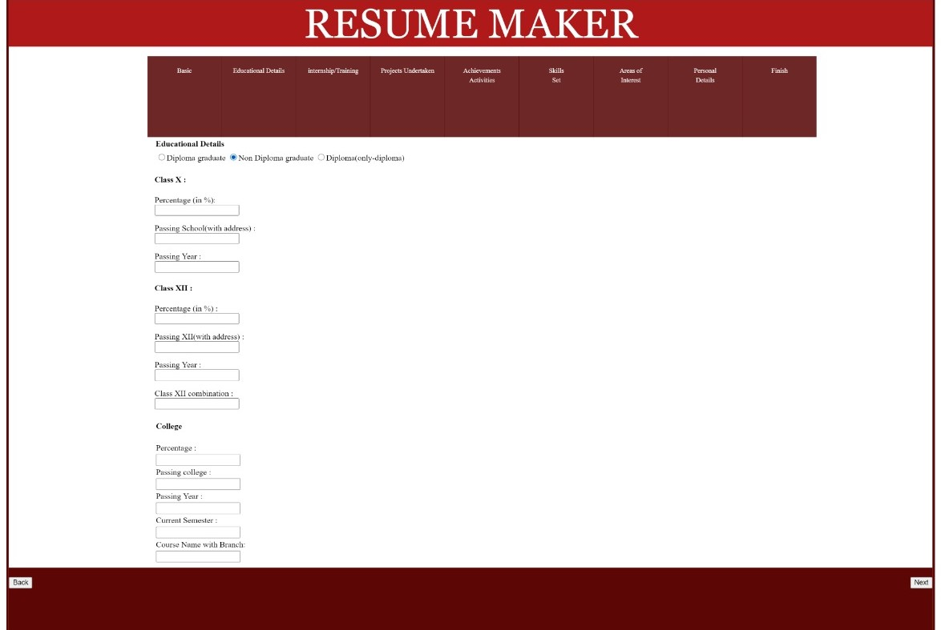
The column in which graduates after 12th class in which details of 10th ,
12th and graduations as to be filled.
Class 10th
- Class 10th percentage – Input your class 10th percentage
- Passing school – School from which you pass your 10th class
- Passing year – Passing year as printed in your 10th passing certificate
Class 12th
- Class 12th percentage – Input your class 12th percentage
- Passing college – college from which you pass your 12th class
- Passing year – Passing year as printed in your class 12th
passing certificate
- Class 12th combination – Science ,Commerce and Arts
19
College
- Percentage – Till date aggregate percentage in college
- Passing College – Name of the college
- Passing year – Year of passing out from college
- Current Semester – Current semester in which you are studying
- Course Name with Branch – Course name with your branch

Only Diploma graduates
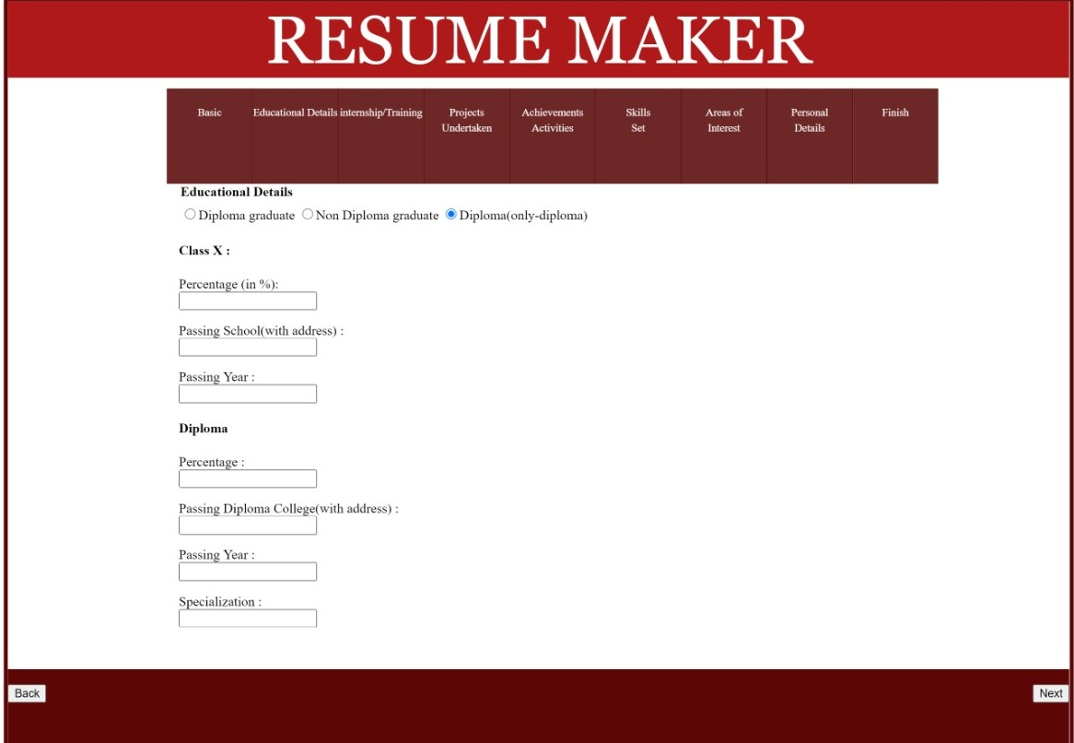
The graduates who have completed only Diploma after their 10th class, in
which details of 10th and Diploma as to be filled.
Diploma
- Percentage - Input your diploma percentage
20
- Passing Diploma college – College from which you pass your
diploma
- Passing year – Passing year as printed in your diploma passing
certificate
- Specialization – Name of diploma
College
- Percentage – Till date aggregate percentage in college
- Passing College – Name of the college
- Passing year – Year of passing out from college
- Current Semester – Current semester in which you are studying
- Course Name with Branch – Course name with your branch
INTERNSHIP/ TRAINING
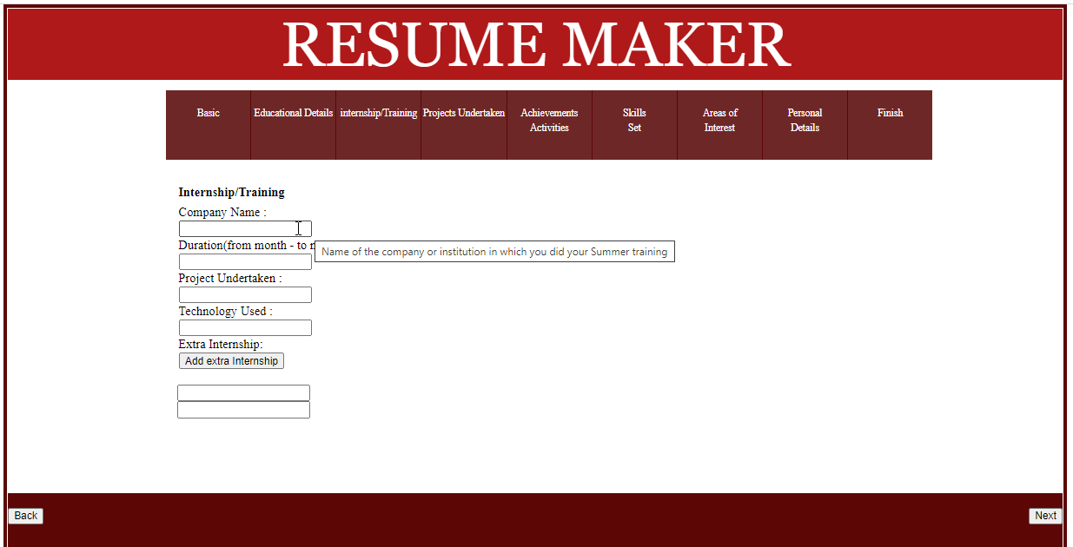
This column includes details of Internship done during the summer , in which Company Name, Duration, Project Undertaken, Technology as to be filled and here there is a option of adding many Internship.
21
- Company Name – Name of the Company or Institution in which you
did your summer training
- Duration – Duration of your training
- Project Undertaken – Name of the project Undertaken in training
- Technology Used – Technology Used in the above mentioned project
PROJECTS UNDERTAKEN
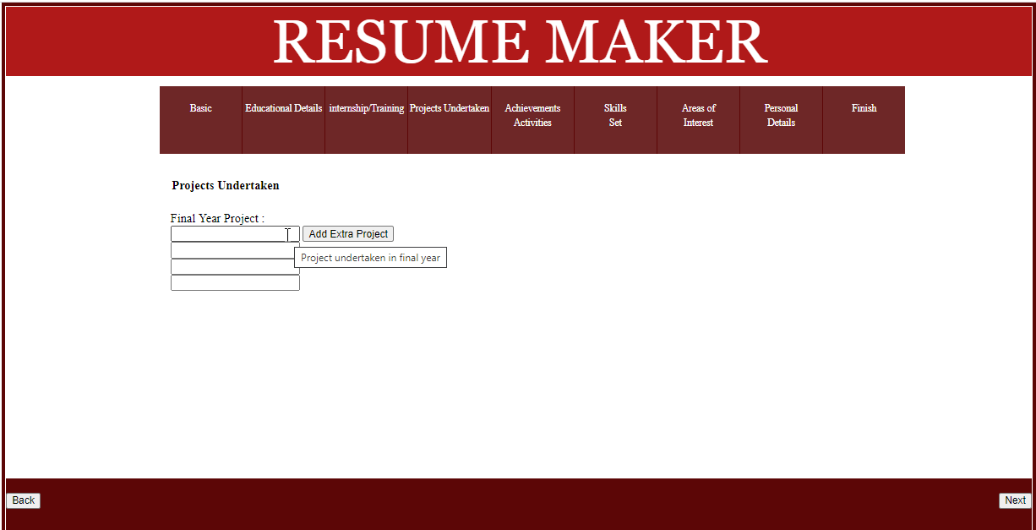
Here comes the details of projects which are done during the final year of
college and there is a option of adding many projects.
- Final year project - Project undertaken in final year
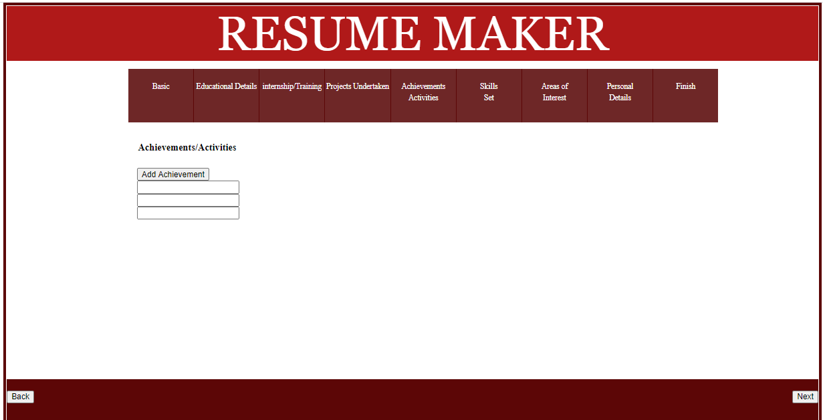
ACHIEVEMENTS / ACTIVITIES
22
The section where you can present your achievements and there is
an option of adding many achievements.
SKILLS SET
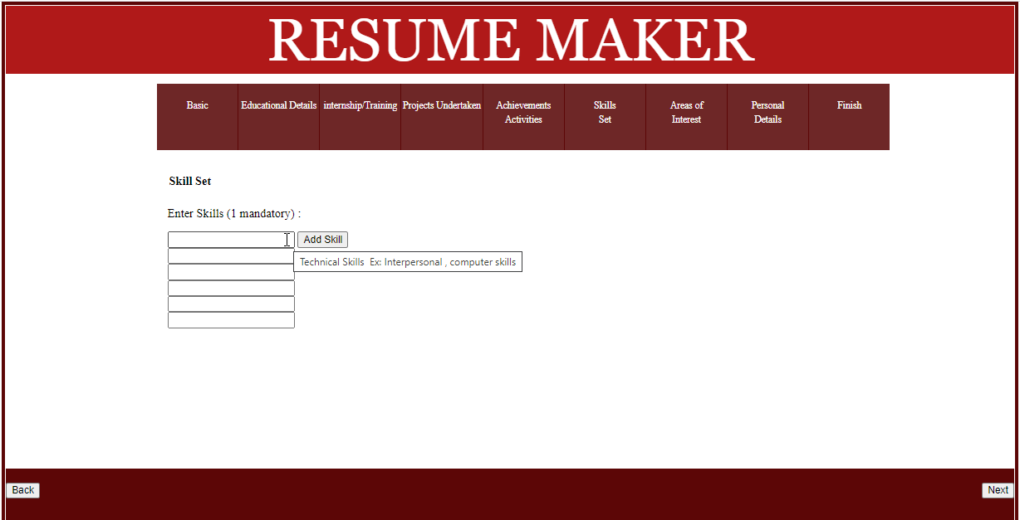
Column where you can represent your skills in which you are expert in and
in which one is mandatory and if many you can add them how much ever you want.
Examples: Interpersonal skill, Computer skill
AREAS OF INTEREST
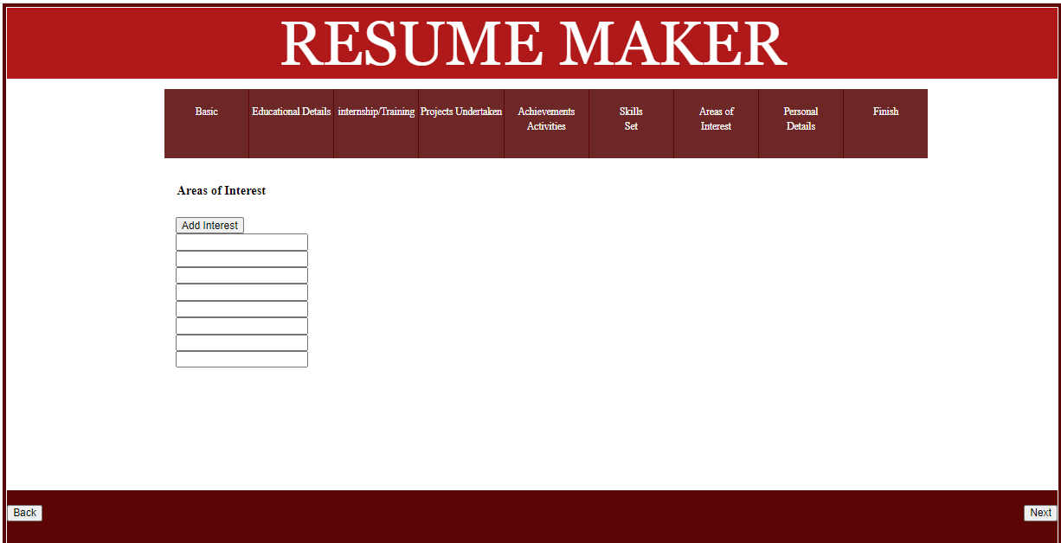
23
The column in which you can enter your area of interest and you can add
how much ever you want.
PERSONAL DETAILS
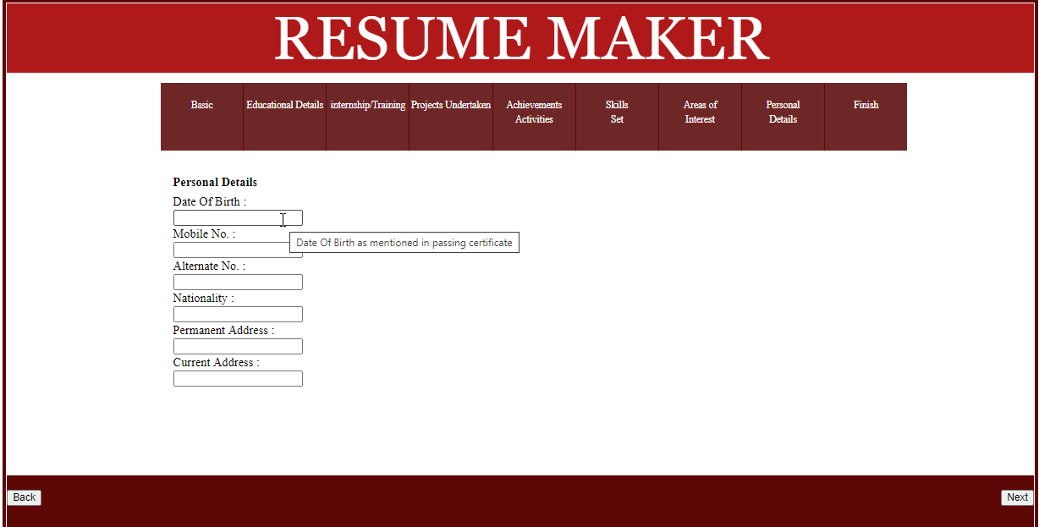
In this column you need to enter your personal details like Date of Birth,Mobile Number,Alternate Number, Nationality, Permanent Address, Current Address.
- Date of Birth – Date of Birth as mentioned in the passing certificate
- Mobile Number – Fixed Mobile Number
- Alternate Number – Mobile or other alternate contact number
- Nationality – Country of which you’re legal citizen
- Permanent Address – Permanent residential address
- Current Address – Current residential address

24
FINISH
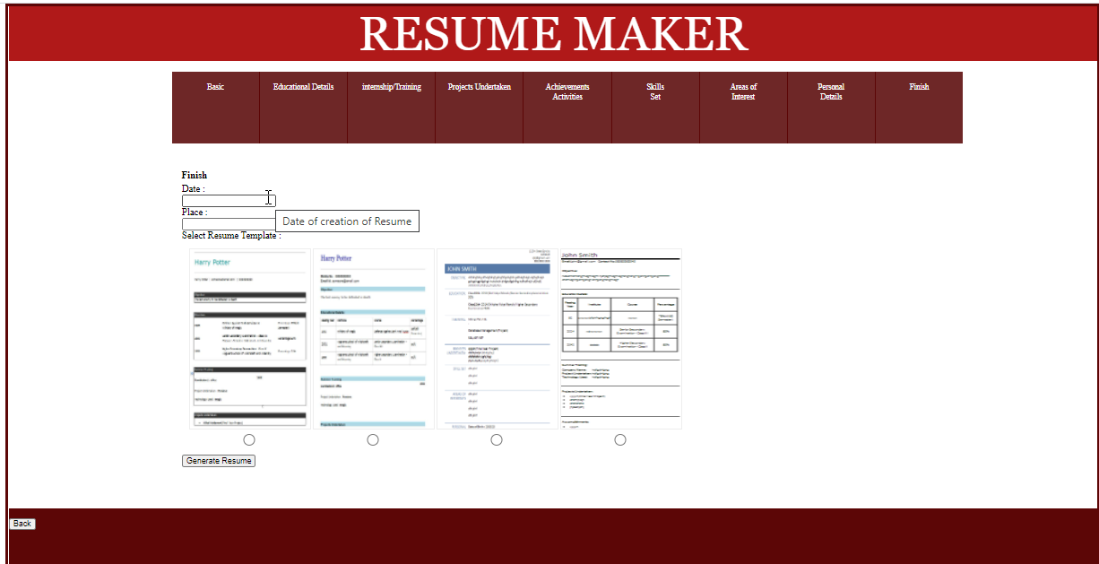
The next step in our resume is the final one which includes Date and Place
after which we have option of generating the resume therefore downloading the resume in four different templates.
- Date – Date of creation of resume
- Place – Location where resume is being created

25

Destination option like OneNote, Save has PDF, Save to Google Drive etc
are provided in this Resume Maker.

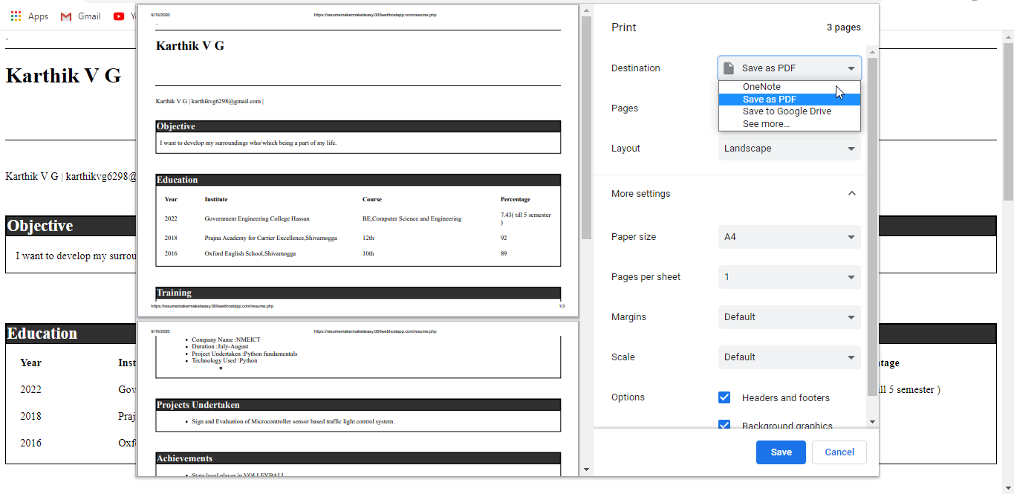

26

Online resume builders are, well, just that. They provide resume document templates which you can customize and download in order to share with recruiters online. These platforms let you create quick, slick resumes suitable for all non-creative industry roles
1.Choose your resume builder
2.Pick your resume template
3.Provide contact information
4.Enter your work experience
5.Preview and customize your resume
6.Sign up for a price plan to download your resume
7.Activate your resume
Step 1: Choose Your Resume Builder
You’re spoilt for choice when it comes to resume builders, so it’s important that you select the right one. Here are our top choices:
Zety (from $5.99/month)
ResumeGenius (free)
ResumeBuild (from $7.99/month)
NovoResume (free)
All of these dedicated resume builders are really easy to use, opening up your career possibilities through beautifully crafted resume templates.
While ResumeGenius is free to use, the other platforms may require you to sign up to a plan in order to download your resume – but it’s never more than just a few dollars.
Some resume builders provide onsite suggestions while you’re creating
27
your resume, while others will let you choose from pre-written work experience bullet points to give your resume that professional, concise look.
All in all, you can’t really go wrong with any of our recommended resume builders.
Step 2: Pick Your Resume Template
The foundation for any solid resume, the template you select could be the difference between your resume and that of an equally experienced competitor. A basic or unsightly template could turn your killer resume into a resu-meh. Don’t rush your choice!
Let’s take Zety, for example. It has 20+ slick, professional resume templates that all come with a cover letter. Again, you can’t really go wrong with any of the templates – they’re all modern and elegant, featuring various types of graphics and colour accents.
Deciding on the design can be one of the most enjoyable phases of learning how to make a resume online, but don’t forget how important it is to pick the one that best reflects your personality.Choose a template with features that can accurately and effectively showcase your experience. For example, some resume graphics may better reflect your fluency in different6 languages, while others may represent your 15+ years in I.T. more appropriately.
Step 3: Provide Contact Information
An unprofessional email address appearing at the top of your resume is a first class ticket to the resume garbage can. Got an embarrassing email address from your teens? Now’s the time to freshen up. Businesses don’t
28
want to hire J0hn$iscoolYO@YOLO.com.
So, once you’ve chosen your resume template, you’ll then need to add your full name, cell phone number, email address, and house address. Adding your street address doesn’t mean recruiters will come knocking – it’s just so they can see where you’re based, because an applicant’s location and potential commute play a big part in the hiring process.

9.CONSTRAINTS
- GOI is only in English.
- Login and password is used for identification of customer and there is no facility for guest.
- This system is working for single server.
- We will use server space for our project, hence we can access through single machine or a number of simultaneous user.
- Another importance is. in case of system crash we will not be needed backup as we can get it from server.

29

10.FIRST LEVEL DATAFLOW DIAGRAM OF ONLINE RESUME MAKER
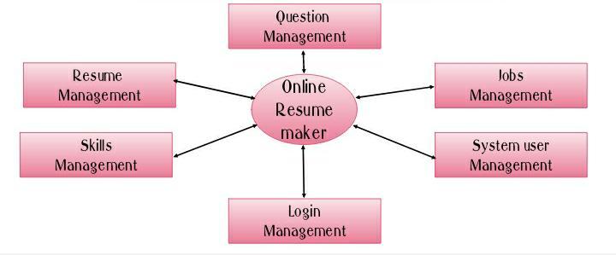
First Level DFD (1st Level) of Online Resume Builder shows how the system is divided into sub-systems (processes), each of which deals with one or more of the data flows to or from an external agent, and which together provide all of the functionality of the Online Resume Builder system as a whole. It also identifies internal data stores of User, Salary, Jobseeker, Question, Job that must be present in order for the Resume Builder system to do its job, and shows the flow of data between the various parts of Resume, Job, Salary, User, Jobseeker of the system. DFD Level 1 provides more detailed breakout of pieces of the level DFD. You will highlight the main functionalities of Resume Builder. Main entities and output of First Level DFD (1st Level DFD):

30
- Processing Resume records and generate report of all Resume
- Processing Skills records and generate report of all Skills
- Processing Job records and generate report of all Job
- Processing Question records and generate report of all Question
- Processing Jobseeker records and generate report of all Jobseeker
- Processing Salary records and generate report of all Salary
- Processing User records and generate report of all User.

8.2 OUTPUT PROCEDURE
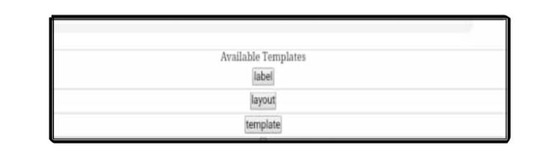
One of the most important factors of an information system for the user is
the output the system produces. Without the quality of the output, the entire system may appear unnecessary that will make us avoid using it possibly causing it to fail. Designing the output should process the in an organized well throughout the manner. The right output must be developed while ensuring that each output element is designed so that people will find the system easy to use effectively.The term output applying to information produced by an information system whether printed or
31
displayed while designing the output we should identify the specific output that is needed to information requirements select a method to present the formation and create a document report or other formats that contains produced by the system.

11.IMPORTANCE OF RESUME MAKER

- Easy and Fast.
- Easy Customization.
- It saves your time.
- Perfect resume formatting.
- It’s a highly affordable option for resume writing.
A resume maker is an online tool that organizes your work history, education and other professional experience into a cohesive resume. Resume builders remove the guesswork from creating a resume. They are especially useful for beginner resume writers, but can be used by any job seeker. Resume builders use resume templates as a guide for their system, so the internal process is very similar to the process you would go through if you simply found a template yourself and filled in all of the requested information (i.e. work history, education, skills). Of course, the benefit of a resume builder is that you don’t have to do all of the work yourself, making it a quick and painless option.
Writing a resume can be an intimidating, confusing task and there is already enough pressure searching for a new job without the headache of making a new resume. Now technology has completely changed so that
32
resume making can be a dynamic, rewarding experience — a time to focus on your goals and achievements, while you leave the details to an online resume maker. So if you’re about to begin your own resume or even updating an existing one, take a deep breath, don’t stress and consider the benefits of using a resume builder.

12.DO’S
- Customize your resume to the sector you are applying to
- First page should catch the attention of the interviewer
- Use bullets instead of paragraphs
- Maintain standard space between sections
- Use keywords that can be read by all machines
- Customize your resume to the sector you are applying to
- First page should catch the attention of the interviewer
- Use bullets instead of paragraphs
- Maintain standard space between sections
- Use keywords that can be read by all machines
- Use formal, readable fonts
- Use font size 12 -14
- Be cautious while mentioning your hobby

33
13.DON’TS
- Don't exceed 2 pages
- Don't exceed 3 to 5 bullets per section
- Don't make spelling and grammar mistakes
- Don't use jargon/slang/acronyms specially acronyms that are proprietary
- Don't include your photograph unless specified by the company
- Don't paste a disclaimer until advised by the company
- Don't copy the objective summary from the internet. Let it be your own
- Don't lie about your achievements.

14.APPLICATIONS OF RESUME MAKER

1. Find the right candidates faster: expand your searches beyond your personal connections and have access to over 500 million LinkedIn members. Search faster with 20+ smart and simple-to-use search filters and recommendations. Our new “Find more people like” feature lets you create a search based on ideal candidates you may know.
2. Contact any candidate via InMail: Use customized templates to reach out to candidates quickly through InMail – LinkedIn’s trusted messaging environment. Enjoy higher response rates than either cold calling or email could ever deliver.
3. Talent Pipeline Management: Build, track and manage the candidates
34
you want to hire now or in the future with folders, reminders and smart to-do lists. Streamline your workflow and team activities with shared projects, searches, profiles, and applicant notes.

15.ADVANTAGES OF RESUME MAKER
- Provides instant resume to individuals.
- There are choices available for resume format for users as per their qualification and requirements.
- Reduces tedious work in thinking and creating resume and is convenient for users.
- Provides quick access and is affordable.
- The system saves time and reduces human efforts.
- Not require you to have design skills.
- Save time and money.
- No need to purchase extra software.
- Professional tips and examples.
- Helps you focus on the content.
- Professional and tested layouts.
- Your information is saved online.

35

16.DISADVANTAGES
- It requires internet connection.
- Sometime user wants customized resume that is not possible in the system.
- Some builders might have limited customization features.
- Cannot choose your own font.
- Not having 100% control over the template.
- Some of them might be hard to use.

17.CONCLUSION
It is an application that simplifies the task of creating a resume for individuals. The system is flexible to be used and reduces the need of thinking and designing an appropriate resume according to qualifications. The system is developed to provide an easy means for creating a professional looking resume. Individuals just have to fill up a form that specifies questions from all required fields such as personal questions, educational, qualities, interest, skills and so on. The answers provided by the users are stored and the system automatically generates a well structured resume. Users have option to create resume in any format and file.
18.REFERENCES
- SQL School: http://www.w3schools.com/sql
- MSDN:http://msdn.microsoft.com
36

